 | PURCHASE REQUEST
Breaking Boards
ITKD Approved Grading Timber
 | 600 Board Pallet
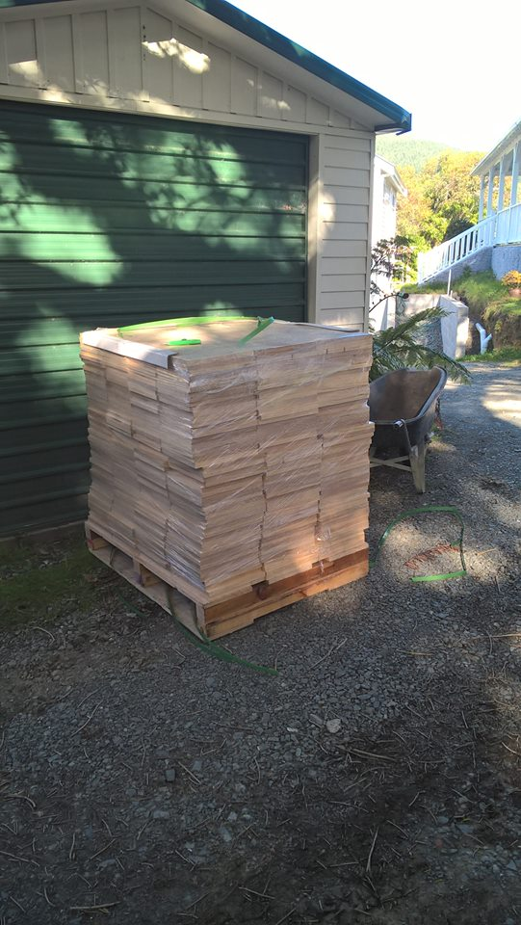
DELIVER TO: | Name: | MUST BE OSITE TO RECEIVE DELIVERY
 | Club:
 | Address: | DELIVERY ADDRESS
 | Tel/Mob: | PERSON WHO WILL BE RECEIVING DELIVERY

transport METHOD | TERMS | REQUESTED DELIVERY DATE
Pallet will be delivered to above address. REQUIRED - Large Truck access to sealed surface (concrete/tarseal) & Delivery contact onsite to take receipt. | Full Payment of “TOTAL” via Internet Deposit to  Bank Account: 06-0529-0444875-02  PRIOR TO ORDER PLACEMENT WITH TIMBER MILL | Note: TIMBER MILL requires minimum 5 working days from Order Placement

QTY | TYPE |  |  | description | ORDER price |  |  | line total
204 | STD |  | JNR |  | ni | si
x1 |  |  |  | Minimum Order = 204Bds (ea price 2.67/2.86) | $545 | $585
x2 |  |  |  | Medium Order =408 Bds (ea price 2.55/2.70) | $1040 | $1100
X3 |  |  |  | Large Order =612 Bds (ea price 2.38/2.55) | $1460 | $1560
* |  |  |  | Residential Delivery (Rural - price on request) | $42 | $42
 |  |  |  |  |  |  | total

- Pricing includes *DELIVERY AND GST to urban commercial zoning. current as at Sept 2025
- *NOTE: Delivery is to most urban locations & location needs to be suitable for large truck access and pallet trolley. Residential deliveries attract additional $42 surcharge. (Rural price on application)
- 204 Boards = 1x pallet. Either ‘Standard’ OR ‘Junior’
- Select SI or NI unit price as appropriate.
- Confirmation of delivery date and any surcharges that may apply will be notified then once funds are received order will be placed
- All correspondence to:
Nick Lee
nick.lee@outlook.co.nz
Mobile: 027-4438497
 | Authorised by | Date

